RaileRobotics Lego Summer Camp Release Form
This form is also on our website https://team935.com/
Parent/Legal Guardian’s Name: ___________________________________________
Address: _____________________________________________________
Phone #’s: Home: (_____) _______-____________
Work: (_____) _______-____________
Cell: (_____) _______-____________
Email Address:_____________________________________________
Children(s) Name(s): | Age & Sex: | Medical Conditions (i.e. allergies)
 | (M/F)
 | (M/F)

Emergency Contact: ____________________________________________________________
Relationship to child/children: ____________________________________________________
Phone #’s: Home: (_____) ______-_________
Cell: (_____) ______-_________
Emergency Contact: ____________________________________________________________
Relationship to child/children: ____________________________________________________
Phone #’s: Home: (_____) ______-_________
Cell: (_____) ______-_________
Names of people allowed to pick your child up: ______________________________________
Parent/Guardian Signature: ____________________________________ Date: ___________
Please wear closed toed shoes (no crocs). Snacks included.
Make checks payable to RaileRobotics and mail to:
900 W 12th St. Newton, KS 67114

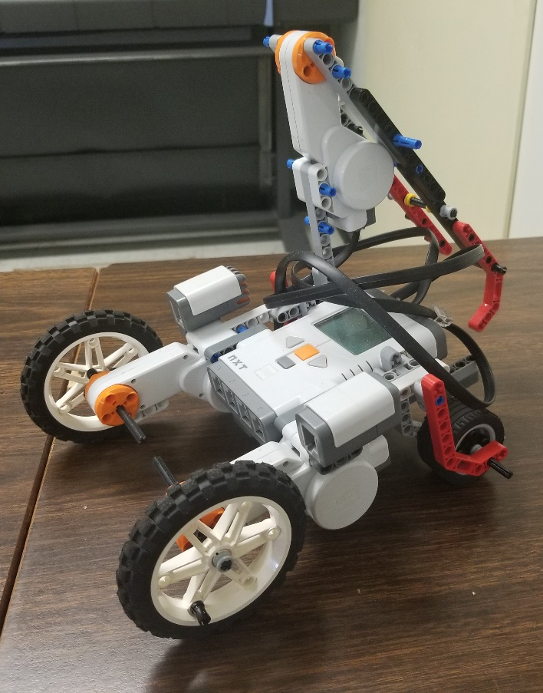
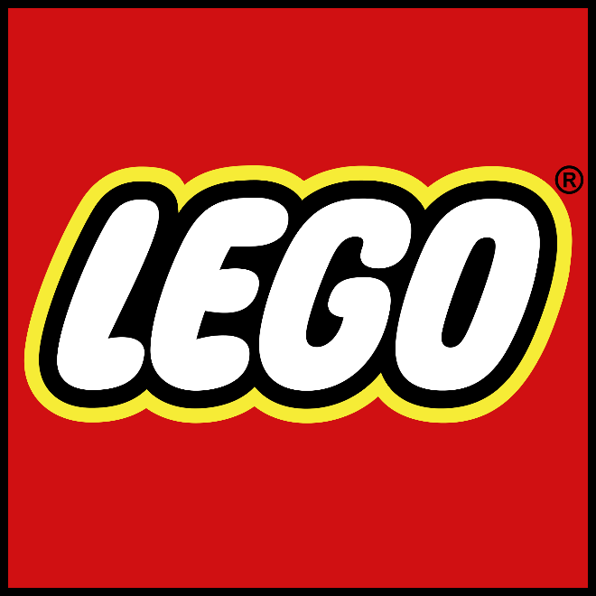
Contact us at: Rgrabe66268@usd373.org
Kenna.graber@usd373.org
Sign up sheet on back
Where: Sunset Elementary
(619 Boyd)
Ages: 8 – 12
Cost: $150 Per Child
When: July 9 – 13th
8 – 11am
SUMMER CAMP

